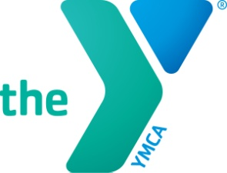
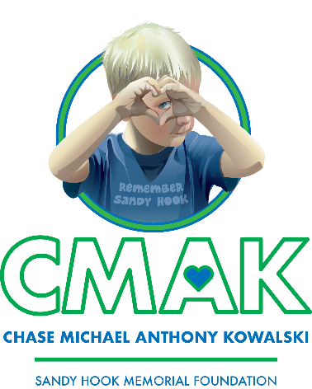

2023 RACE4CHASE
TRIATHLON APPLICATION

Race4Chase is named for Chase Kowalski, an amazing little boy from Newtown CT, who loved to swim, bike and run. Race 4 Chase provides youth with a fun, skill building, life-changing experience by introducing them to the sport of triathlon.

PROGRAM DETAILS

AGES 6 – 12 years
DATES June 26 - August 5, 2023
DAYS Monday – Friday
TIME Drop-off 9:00 AM / Pick-up 12:00 Noon
LOCATION Stratford YMCA, 3045 Main St, Stratford CT 06614
RACE DAY Saturday, August 6
YMCA Camp Sloper, 1000 East Street, Southington CT
COST FREE

Due to limited space, selection priority will be given to first time registrations, a demonstration of need, and those indicating a sincere desire to participate for the complete duration of the program.

Complete one application per child. If selected, completion of a registration packet is required.

Print and return completed application/s by April 28, 2023 to:
Stratford YMCA
3045 Main Street – Stratford, CT
Attention: Ashley Fedak, Membership and Health & Wellness Director

Participants will try to meet a fundraising goal of $250 before 7/24/2023. Every dollar donated to the Stratford YMCA stays in our communities and directly serves youth and families in need. We will help participants with ideas to meet their fundraising goal.

STRATFORD YMCA
3045 Main Street, Stratford CT 06614
P 203 375 5844 F 203 380 0291 W stratfordymca.org
Parent’s section (please print clearly)

Childs Name ____________________________________________________________________ Birth Date ____/____/_____ Sex (M/F) _________
Address _________________________________________________________ City _______________________________________ Zip ________________
Parent #1 ____________________________________________________________________________ Cell phone #____________________________
Email ____________________________________________________________ Home phone #______________________________________________
Parent #2 ________________________________________________________________________ Cell phone #________________________________
Email ___________________________________________________________________ Home phone #____________________________________________
What is your child’s activity level and frequency?
_________________________________________________________________________________________________________________________________________________________________________________________________________________________________
________________________________________________________________________________________________________________________________________________________________________________________________________________________________
What is your child’s swimming ability (check one)
________ Beginner ________ Intermediate ________ Advanced
What is your child’s biking ability (check one)
________ Beginner ________ Intermediate ________ Advanced
How would you describe your child’s overall heath?
_________________________________________________________________________________________________________________________________________________________________________________________________________________________________
What are your child’s favorite activities?
__________________________________________________________________________________________________________________________________________________________________________________________________________________________________
How will your child benefit from participating in this program?
_________________________________________________________________________________________________________________________________________________________________________________________________________________________________
________________________________________________________________________________________________________________________________________________________________________________________________________________________________
Child’s Section (Parents can help write and spell if needed.)
Why do you want to participate in the Race4Chase program?
_________________________________________________________________________________________________________________________________________________________________________________________________________________________________
________________________________________________________________________________________________________________________________________________________________________________________________________________________________
What do you like to do for fun?
______________________________________________________________________________________________________________________ ______________________________________________________

